Mapping Exercise

Map the multimedia assignment on the next page using the lists of objectives from the CSU Anywhere mapping case study and the blank spaces below.
National > Institution > College > Department > Course > Artifact Level Goals

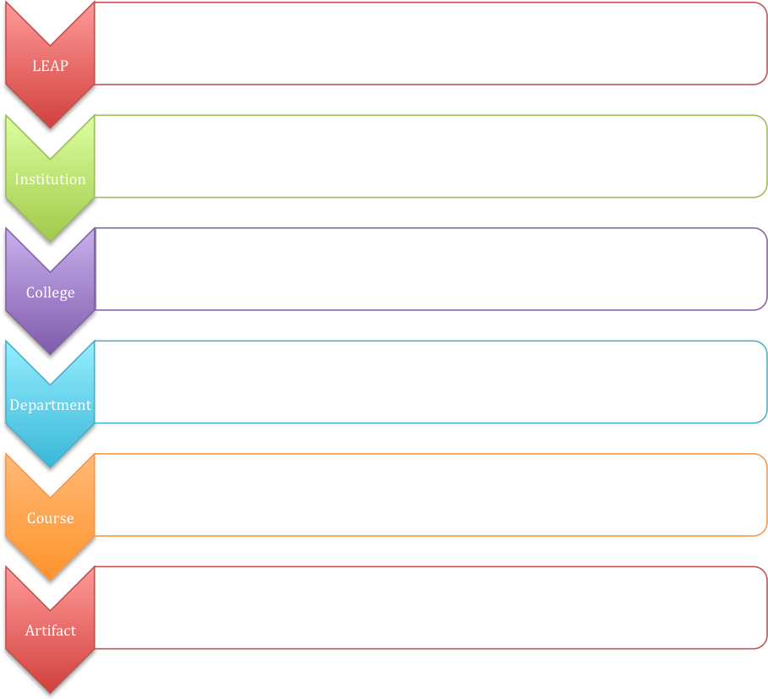

Multimedia web research project: Environmental Studies 101

You will be creating an independent multimedia research project that describes and analyzes specific scientific, cultural, artistic, linguistic, economic and/or political aspects of the Monterey bay region as an ecological "place." You will construct a web site that explains your project’s thesis, methods, literature review, evidence, arguments and conclusions. The online project also will incorporate relevant supplementary materials, which may include electronic documents, GIS maps, photos, graphics and/or video/audio clips. Although the projects are individually based and evaluated, collaboration among class members is encouraged.

REQUIRED COMPONENTS
Unlike a printed research paper that must proceed sequentially, your web-based project can assume a variety of organizational structures, depending on the needs of your topic and your intellectual and creative approach. No matter what organizational arrangement you choose, your project must include the following elements:
- An introductory page that describes the project and provides a clear navigational framework
- A literature review of the significant published research that is relevant to your project
- A description of your methodology: Will this project be based on statistical analysis, GIS mapping, interviews, questionnaires, interpretative textual analysis or some other methodological approach?
- A presentation of the empirical evidence and your analysis of that evidence
- A conclusion that describes the significant outcomes of your project and its implications for environmental knowledge and understanding.
- A complete works-cited list that follows a recognized citation style. (One modification, however: Because an indented format is not possible on web pages, double-space between each reference.)

SUPPLEMENTARY COMPONENTS
The multimedia format of this research project allows you to integrate textual and nontextual displays of your empirical evidence (e.g., photos, audio clips of original interviews, text documents, graphics, maps) and other supplementary materials that will help your readers gain greater knowledge of the project.

